

**CSE6224 SOFTWARE REQUIREMENTS ENGINEERING**

**TRIMESTER 2510**

**Project Part 1**

**Context Object**

**Contents**

**1.0 System Context 3**

1.1 System Context Overview 3

1.2 External Entities (Actors and Systems) 3

1.3 System Boundary Overview 3

1.4 Context Diagram 4

**2.0 Context Objects 5**

2.1 Material Context Objects 5

2.2 Immaterial Context Objects 5

2.3 Development Context Objects 6

**3.0 Sources of Requirement 7**

3.1 Introduction 7

3.2 List Of Sources 7

3.3 Stakeholders 8

3.4 Constraints 9

3.5 Functional Requirements 9

3.6 Non-Functional Requirements 10

# **1.0 System Context**

### **1.1 System Context Overview**

The Campus Wellness Portal is an integrated system that connects students, medical staff, fitness center staff, fitness coordinator and administrators with supporting external systems such as medical appointment software and fitness scheduling software. The portal enables scheduling, tracking, goal-setting, and personalized wellness interactions.

### **1.2 External Entities (Actors and Systems)**

|  |  |  |
| --- | --- | --- |
| **External Entity** | **Type** | **Description** |
| Student | Human Actor | Uses the portal to manage personal wellness: bookings, goals, schedules. |
| Medical Staff | Human Actor | Provides health services, monitors progress, and updates medical records. |
| System Admin | Human Actor | Maintains the system, monitors performance, and manages accounts/ content. |
| Medical Software System | External System | Integrates appointment reminders, reservations, and health media. |
| Fitness Software System | External System | Integrates class schedules, slot availability, and bookings. |
| Fitness Coordinator | Human Actor | Manage schedule, add classes, assign classes, send announcements |
| Notification System | External System (Optional) | Sends alerts/ reminders to users. |

### **1.3 System Boundary Overview**

The Campus Wellness Portal:

* Is responsible for: User interfaces, managing appointments, wellness goals, fitness bookings, data storage, sending notifications, dashboard views, etc.
* Relies on external system for: Appointment handling (via medical software), fitness schedules (via fitness software), and possibly notifications.

### **1.4 Context Diagram**

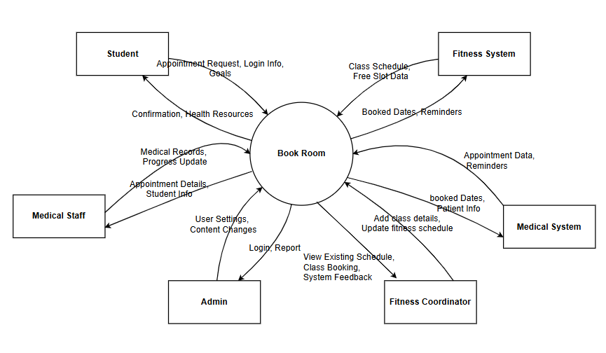

# 

# **2.0 Context Objects**

### **2.1 Material Context Objects**

|  |  |
| --- | --- |
| **Object** | **Description** |
| Student | Primary users who schedule appointments, book fitness classes, etc. |
| System Admin/ Management | Responsible for overall system oversight, content, and user management. |
| Medical Staff | Healthcare providers who manage medical info and appointments. |
| Computers / Kiosks | Devices used to access the system in clinics or fitness centers. |
| Server Hardware | Backend servers hosting the portal and managing data. |
| Medical Equipment | Devices used by medical staff to gather health data (e.g., blood pressure monitors). |
| Fitness Center Equipment | Used by students to track progress (e.g., smart treadmills, body scanners). |
| Printed Health Records | Occasionally printed versions of reports or appointment summaries |

### **2.2 Immaterial Context Objects**

|  |  |
| --- | --- |
| **Object** | **Description** |
| User Account | Digital identity of students and staff in the portal. |
| Appointment Data | Scheduled appointment details stored in the system. |
| Health & Fitness Goals | Personalized digital goals set by students. |
| Notifications/Reminders | System-generated alerts for upcoming events. |
| Medical Software System | External system integrated to handle health center functions. |
| Fitness Software System | External system integrated for fitness class scheduling and management. |
| Digital Health Records | Electronic versions of medical history and updates. |
| System Logs | Records of user actions and system performance data. |

### **2.3 Development Context Objects**

Understanding the development context is crucial because it directly impacts the feasibility and scope of requirements. Budget, timelines, tools, and team capabilities all shape what can realistically be delivered. Identifying both material and immaterial development context objects helps ensure that the system is developed within real-world constraints while meeting stakeholder expectations.

|  |  |
| --- | --- |
| Object | Description |
| Development Tools | Software like Visual Studio Code, GitHub, and project management platforms. |
| Hardware | Laptops, servers, and networking devices used during development. |
| Share Storage | Online repositories or shared drives where project files are stored. |
| Budget | Financial limitations that may restrict tool selection or feature complexity |
| Time Constraints | Deadlines for project phases (e.g., SRS delivery, prototype submission) |
| Team Skills/ Experience | The knowledge and capability of developers and analysts in using tools/ methods. |
| Project Plan | The timeline and task breakdown guiding the development workflow |
| Development Standards | Coding and documentation standards that must be followed. |
| Client Requirements | Stakeholder expectations that must be fulfilled. |

# **3.0 Sources of Requirement**

### **3.1 Introduction**

Multiple sources were used to gather comprehensive and accurate system requirements. Questionnaires provided broad input from end users such as students and staff, while online sources offered insights into industry standards and similar systems. Additional context was obtained through stakeholder involvement and analysis of existing systems to ensure the Campus Wellness Portal meets real-world needs and integrates smoothly with current university infrastructure.

### **3.2 List Of Sources**

|  |  |
| --- | --- |
| **Source** | **Description** |
| Student. Medical Staff, Admin, Fitness Staff (Stakeholders) | Gathering requirements directly from users like students, medical staff, and admins who will interact with the system. |
| Campus Wellness Portal (Existing Systems) | Analysing current medical and fitness software for integration points and existing workflows that must be supported. |
| Interviews (Optional) | Expected to guide usability and wellness feature development. |
| <https://portal.uwaterloo.ca/campusWellness> (Online Sources) | Used to research similar systems, best practices, feature sets, and usability trends to inform system requirements. |
| Document Analysis (Optional) | Reviewing existing policies, system guides, or procedures to identify requirements, constraints, and standard. |

### 

### **3.3 Stakeholders**

A stakeholder is any individual, group, or organization that has an interest in, is affected by, or can affect the outcome of a project. In the context of software development or system design, stakeholders can be:

* Direct users of the system
* Support personnel who maintain or manage it
* Decision-makers or funders
* External systems or partners the system interacts with

The following table identifies the stakeholders for the project.

|  |  |  |
| --- | --- | --- |
| Stakeholder | Interest | Impact |
| Student | The end user for the system.  As the primary user, they have an interest in ensuring that the system performs the required functionalities for the user to be able to perform their operations. | The entire system is built around their convenience and involvement. The usability of the system and feature design are all shaped according to their interest and feedback. |
| Medical Staff | The medical staff has an interest in managing the health of the students. | The system should incorporate their workflow to avoid any unnecessary complication. |
| IT Support Unit | The IT Support unit has an interest in ensuring the system can be supportable by the organization and that all artifacts delivered will be usable and accurately reflect the procedures necessary to be supported by the system’s resources. | Must help in implementing the system's backend and database. |
| Fitness Coordinator | The fitness coordinator has an interest in managing the physicality of the students. | The system should incorporate their workflow to avoid any unnecessary complication. |
| System Admin | The system admin has an interest in ensuring the system’s cost, schedule, quality, risks and issues are carefully monitored, managed and that newer implementations of functionality be approved. | The system must comply with the admin's visions, missions, and terms and conditions to drive operational priorities. |

### 

### **3.4 Constraints**

These are limitations or restrictions the project must operate within:

|  |  |
| --- | --- |
| **Constraint** | **Description** |
| Time | The project must be completed within a set limit of time. |
| Budget | The project must operate within a fixed budget. |
| Privacy | The system must comply with data protection laws regarding health and personal information. |
| Integration | Limited to existing university systems only ; no third party wellness apps will be connected. |
| User Authentication | Only personnels with official university accounts can access the platform. |
| Device Compatibility | The platform must function on commonly used browsers. |
| Data Storage Location | All data must be stored on university-approved servers due to security and compliance requirements. |
| Staff availability | The availability of medical and fitness staff to use the platform may be limited due to working hours. |

### **3.5 Functional Requirements**

Functional requirements are the requirements that the end user specifically demands as basic facilities that the system should offer. All these functionalities need to be necessarily incorporated into the system as a part of the contract.

1. The system allows secure login using their university credentials.
2. The system enables students to schedule appointments with the university health center.
3. The system allows students to book fitness classes based on available slots.
4. The system provides a timetable for time management.
5. The system allows students to set, view, and track personal wellness goals.
6. The system sends students event reminders for upcoming appointments or classes.
7. The system promotes personalized health and wellness content.

### **3.6 Non-Functional Requirements**

Non-functional Requirements are the quality constraints that the system must satisfy according to the project contract.

The following table identifies the quality constraints involved in the execution of the project and/or the artifacts produced.

|  |  |
| --- | --- |
| **Issues** | **Description** |
| Portability | System is accessible on desktop devices. |
| Security | Protect user personal data, such as personal health records and to allow only authorised users to access system features. |
| Maintainability | System is modular and well-documented to allow for easy updates, troubleshooting, and repair. |
| Availability | Be available to use every semester, excluding semester break and public holidays. |
| Reliability | Support at least 100,000 users. |
| Performance | Process reservation and booking in real-time. |
| Reusability | Provide a user-friendly and intuitive interface without any in-depth technical background. |
| Flexibility | Integrate smoothly with the existing university health and fitness system. |